I have learned a lot about descriptive and inferential statistics and data analysis throughout this course, especially when it comes to using R. When I was first exposed to R, I was still a little hesitant to use it because I still had difficulty becoming familiar with its syntax and libraries. But I was able to overcome these challenges and improve my R skills with practice and the help of internet tools and course materials.
With a special focus on real-world data science applications, Andrew Bruce and Peter Bruce's book "Practical Statistics for Data Scientists" offered a thorough review of statistical ideas and methods. Also, the "Statistics for Data Scientists" GitHub repository, is another excellent resource. Many statistical subjects are covered by the data sets and R scripts that are included. Through practicing coding while analyzing results, I was able to follow along with the book's chapters.
Producing summary tables, contingency tables, and plots using R was an essential aspect of exploratory data analysis in this module. Initially, I found it challenging to choose the right graphs to plot data that effectively visualized the data. However, with practice and experimentation with different R packages such as ggplot2 and dplyr, I’m now confident in plotting categorical and continuous data values (see Appendix 1 & 2, adopted from Crime Survey for England and Wales, 2013-2014 under Unit 2 data activity).
Interpreting statistical findings using p-values and confidence intervals was an integral part of this module. Through practice and guidance from the course materials, I gained a better understanding of how to interpret p-values correctly. I now know that a small p-value (<0.05) indicates strong evidence against a null hypothesis in favor of the alternative hypothesis (see appendix 3).
Similarly, I’m now confident in interpreting confidence e.g. supposing the R output for 95% confidence interval for the mean reduction in blood pressure is (2.5, 5.0), this implies that we are 95% confident that the true mean reduction lies within this range. The interval does not include 0 value therefore we would reject the null hypothesis. (see appendix 3).
I've shown improvement in my understanding of data analysis during this course. First, the approach of exploratory data analysis was introduced to during Unit 1. I learned how to import several types of data into R, summarize data and interpret e.g. when Median = -0.185 and Mean = -0.007, here the mean > median indicating right skewness in the data as seen with the histogram. Therefore, the median is more appropriate to define the data (See appendix 4).
During data activity 4, I gained valuable hands-on experience in data visualization and interpretation, which are essential skills for analyzing and understanding data in various fields (see appendix 5). I took a statistics quiz to see how much I knew about the subject, and on my first attempt, I received a score of 100. This indicates that I can exhibit a thorough understanding of the ideas, strategies, and tactics covered in this module (See appendix 6).
I am aware of the differences between parametric and non-parametric hypothesis testing techniques. I can conduct a hypothesis test to see whether there is any correlation between two variables. During data activity 5, in this instance, we evaluated the relationship between systolic blood pressure and the existence or absence of peptic ulcer using an appropriate hypothesis test after performing normality test on the variables. By examining the results of the hypothesis test, I am able to determine if there is a statistically significant association between the two variables. I discovered that the p-value > 0.05 shows that there is no association between sbp and peptic ulcer (See appendix 7 & 8). Furthermore, I performed data activity 7 and 8 and was able to interpret results from a chi-square test and correlation (See append 9 & 10).
I gained knowledge of basic linear regression analysis during Data Activity 9, which helped me identify the population regression equation for predicting diastolic blood pressure (BP) based on systolic blood pressure. I gave an example of how to interpret regression analysis results at the 5% significance level (See appendix 11).
For me, completing this module was a thrilling experience. At my current job, where I manage data, I've always desired to expand my skill set. For me, mastering inferential statistics in particular has helped me advance from doing routine data management tasks to being able to support scientific research as well.
Roediger et al. (2014) argue that learning can actually be improved by struggling with new knowledge, such as when a lecture and literature provide material in a different perspective. This process of having to reconcile different presentations of information helps to solidify understanding and retention of the material. Despite the fact that learning statistics has not been easy, I have managed to understand ideas by attending live seminars and asking questions whenever I had the chance. I have been able to understand the most of the material by replaying the seminar videos and doing all of the data activities.

References:
Roediger, H.L., McDaniel, M.A. and Brown, P.C., 2014. Make it stick: The science of successful learning. Harvard University Press.

Appendix 1

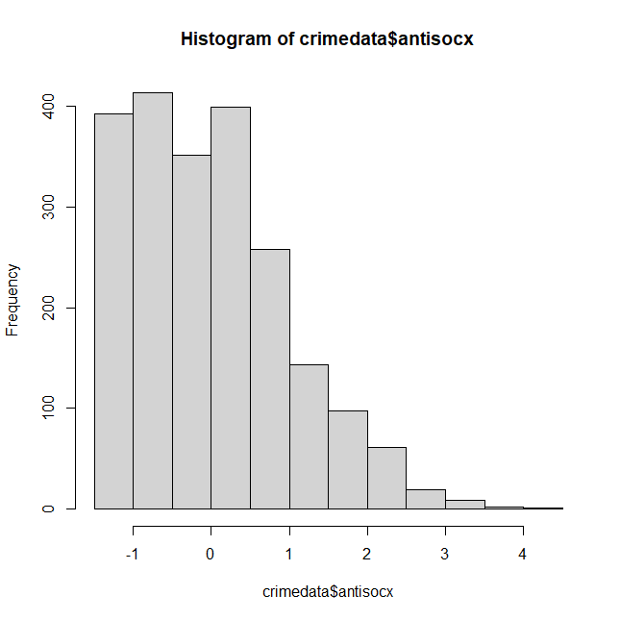

Appendix 2
Descriptive statistics on respondents experienced any crime in the 12 months prior to the survey
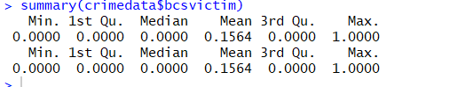

Appendix 3
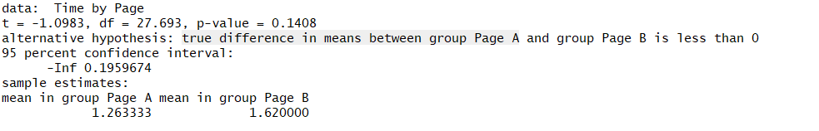

The 95% confidence interval for the difference in means (-Inf, 0.1959674) includes zero. Therefore, we cannot conclude that there is a significant difference in the mean time spent on the page between the two groups

Appendix 4
Unit 1 & 2 data activity
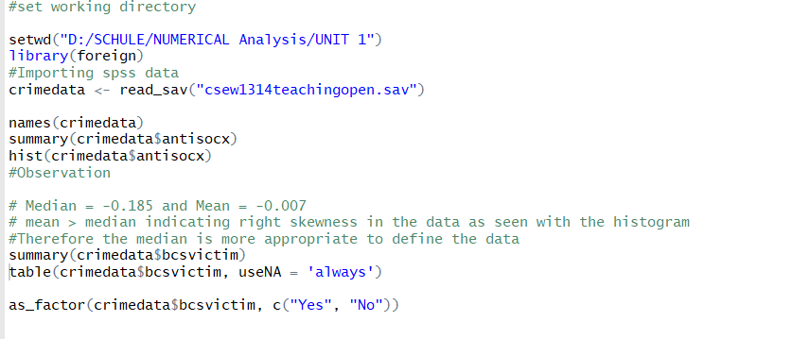

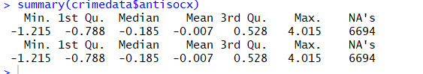

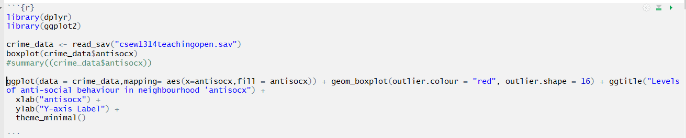
Appendix 5

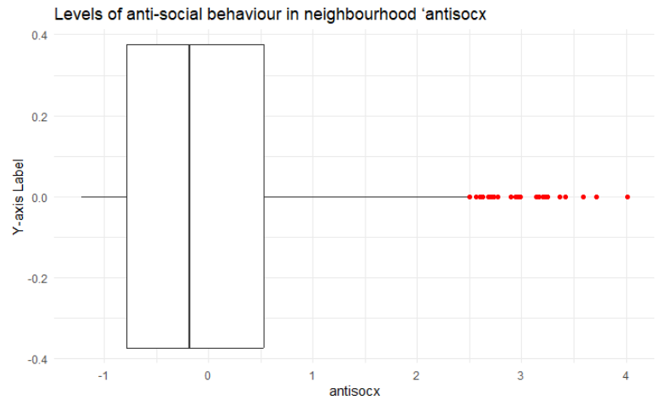

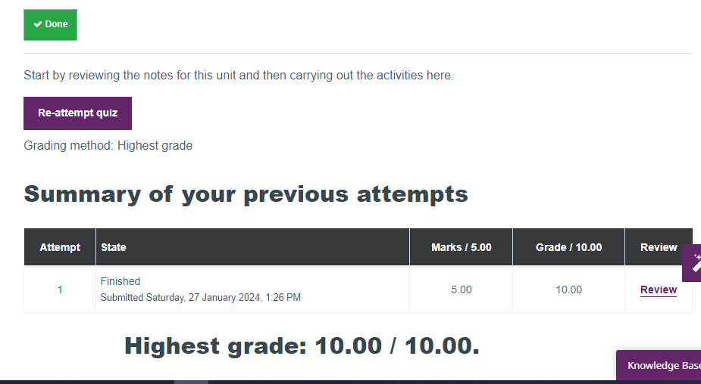
Appendix 6
Appendix 7
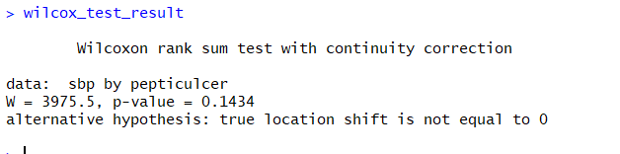
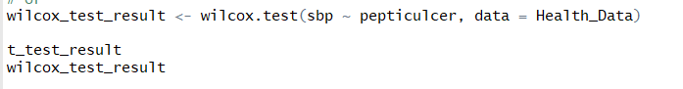

Appendix 8

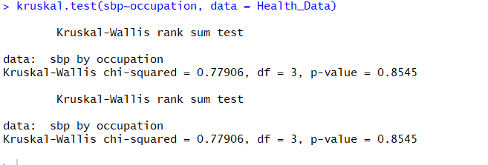

Appendix 9
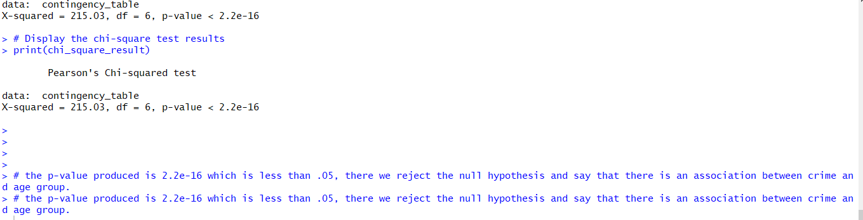
Appendix 10
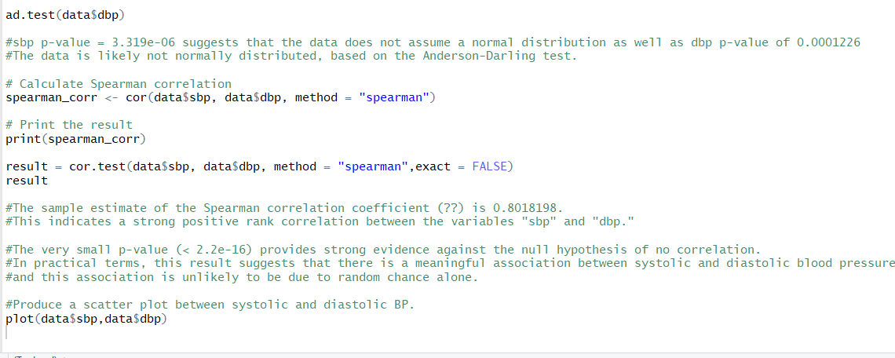
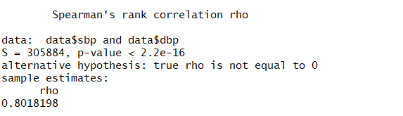

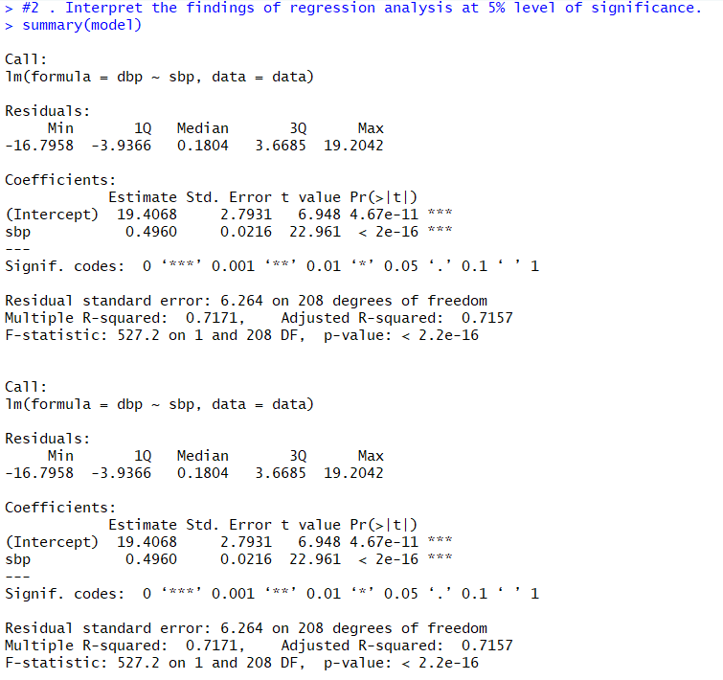
Appendix 11

